Q1. Implement a queue using 2 stacks. The stacks should be an array of some max size.

A queue can also be implemented using two stacks. One stack is used to enqueue elements, while the other is used to dequeue elements. That is, when an element is added to the queue it is pushed on the in stack. When an element is removed from the queue it is popped off the out stack. If the out stack is empty, the contents of the in stack is transferred to the out stack.

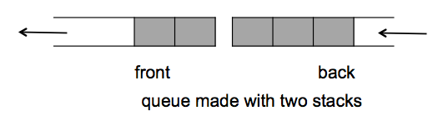

Implement the methods of the TwoStackQueue.

Run your program with a mix of enqueue and de-queue operations (at least 5 enqueus and 5 dequeues. Each time printing a message “item <#> enqueued” OR “Item <#> dequeued” . Submit screen shot.

Q2. Implement the following methods for a single linked list:

1. Insert – Insert so that the list is sorted in ascending order. Initially the list is empty. You will insert at least 10 integer numbers in the list at the right position so that the numbers are sorted.
2. Delete – Deletes a node given a key value. If the key is not found, the delete will print message “Key <number> not found”
3. Traverse – print all the numbers in the list. (they would be printed in ascending order.

Run your program 3 times.

1. Insert 10 numbers and then traverse them to show the list of 10 numbers in ascending order. Submit a screen shot of this output
2. Delete 3 numbers. 2 of them are in the list and one should be a number not in the list. Then traverse the list …

The output will show 8 numbers in the sorted and also the message for the number not found.

For both the questions submit the code files also.